HCP2C01 – Smart Templaate

|  |  |
| --- | --- |
| **Product**  HANA Cloud Platform  **Level**  Undergraduate/Graduate  Beginner  **Focus**  HANA Cloud Platform  **Author** Ross Hightower | MOTIVATION  This case describes registering for a developer trial accounts on SAP cloud services.  **PREREQUISITES**  None |

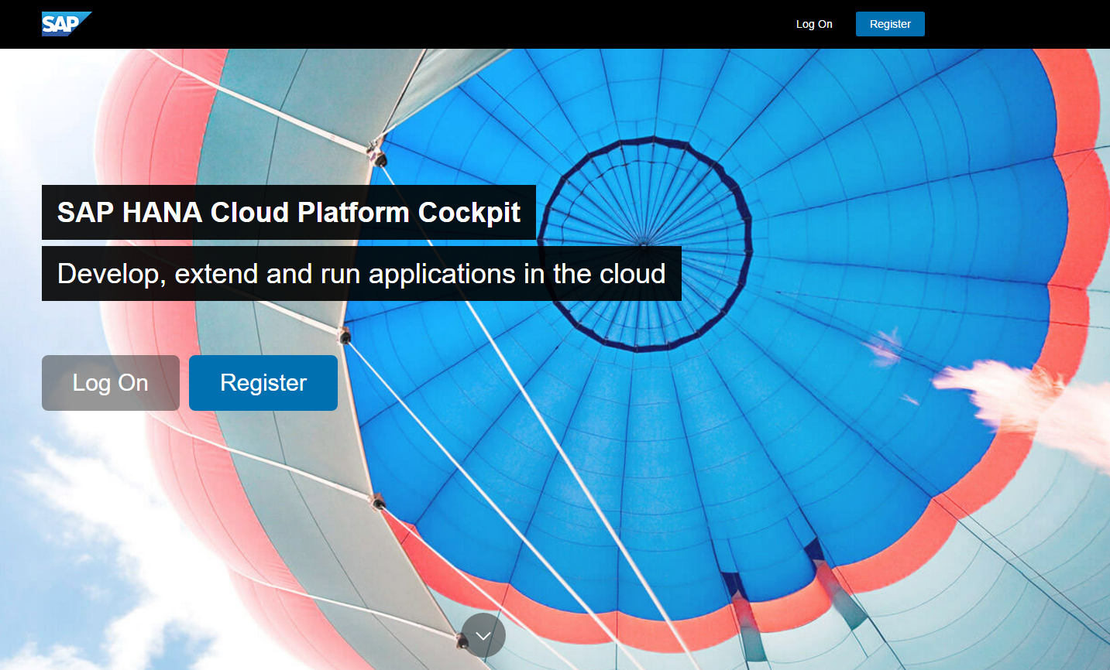

# Registering for Accounts

The cases in this course use a number of free trial services provided by SAP. This case takes you through the process of creating accounts on these services. The services include:

* SAP HANA Cloud Platform
* SAP NetWeaver Gateway Demo System
* SAP Fiori Launchpad Demo Edition
* SAP Splash & Build

|  |
| --- |
| If you have already registered for any of these services or already have an SAP Community Network (SCN) id, you should use the same email to register for the other services. That allows your accounts to be linked. |

Although other browsers may work, SAP recommends you use Google Chrome.

## HANA Cloud Platform

Navigate to <https://hanatrial.ondemand.com>. To create an account click **Register**.



Fill in the Registration form and click **Register**.

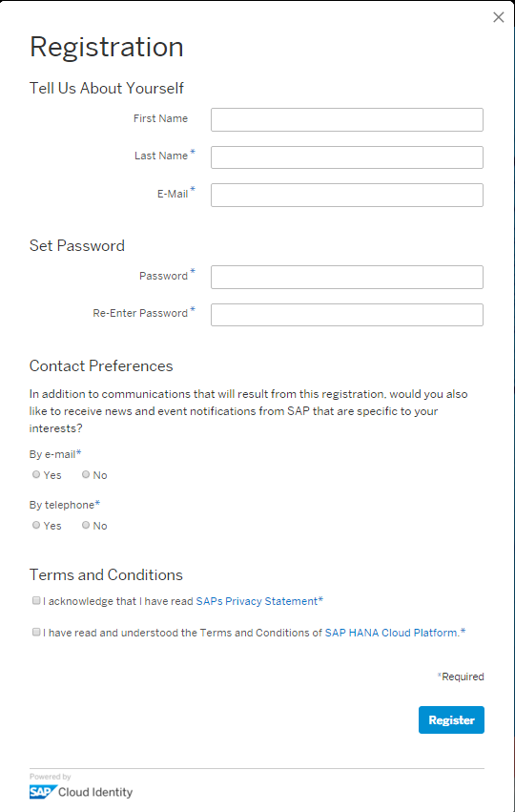

You will receive an email with a link that allows you to activate your account. Once you activate your account click Continue to proceed to the HCP Cockpit which is the administrative tool for HCP. You will also receive another email with links to several useful resources.

You can access the HCP Cockpit using [**https://account.hanatrial.ondemand.com/cockpit**](https://account.hanatrial.ondemand.com/cockpit).

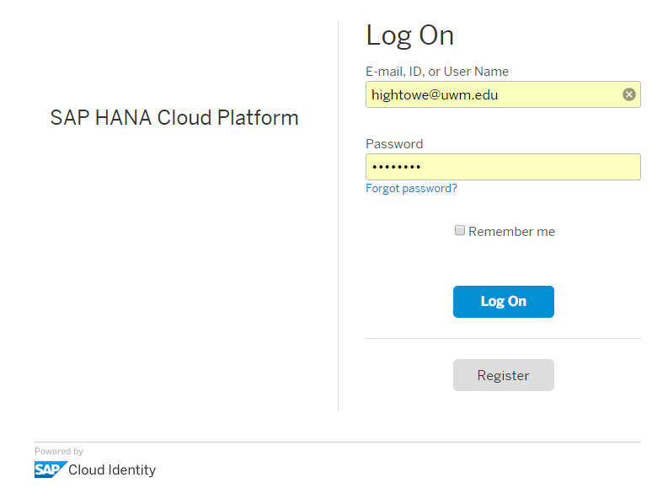

When you log on to the cockpit you will often see a dialog that shows News and Announcements which describe updates to the platform. The platform can evolve quickly.

The first screen you will see is the Dashboard which provides a summary of the state of your account.

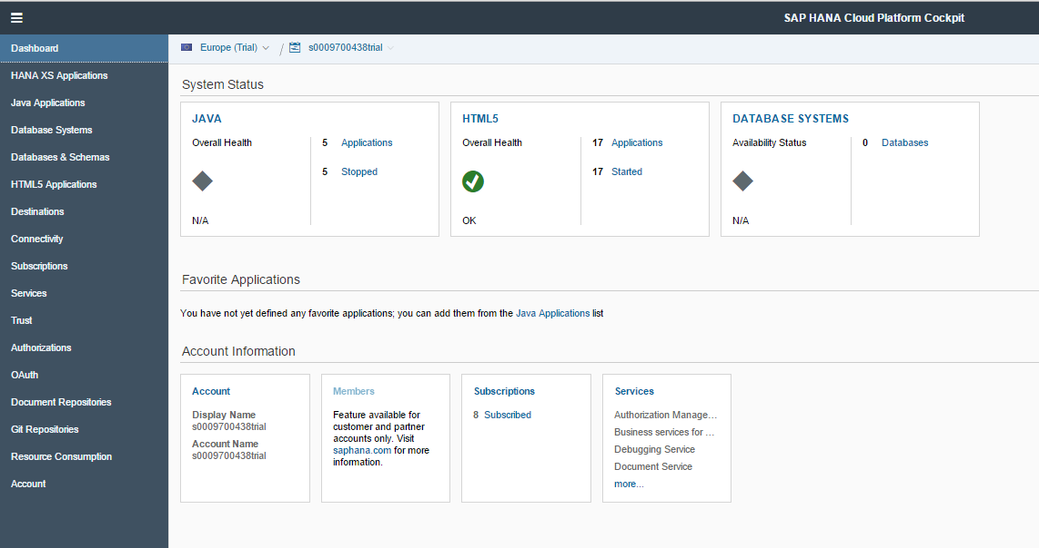

Note the bread crumb navigation near the top of the page. This shows the name of your account (ending in trial), the datacenter where you are hosted (Europe in the image below) and the page you are on (SAP Web IDE configuration on the image below). You can return to the top level by clicking your account id.



### Setup Web IDE

Navigate to **Services** using the menu on the left side of the screen (you can click the menu icon in the top left to expand the side menu). This screen shows a variety of services which can be activated.

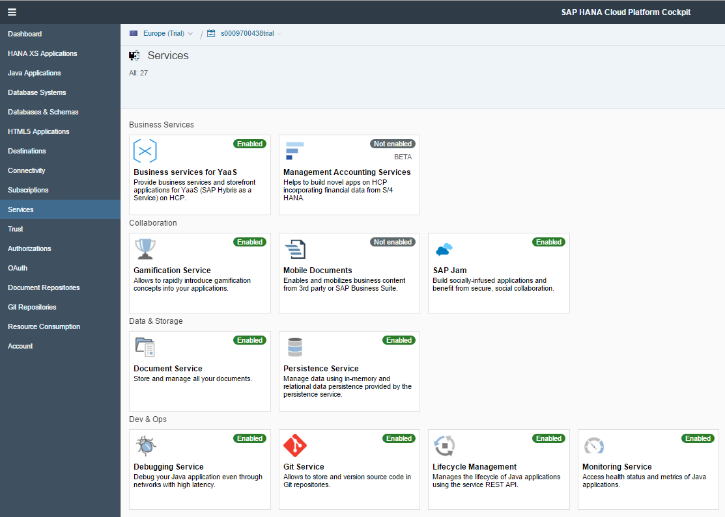

Locate the card for the Web IDE services. Click the card to open the service configuration page.

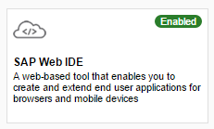

If the service is not enabled, click the Enable button to enable it. The chip will turn green and say Enabled.

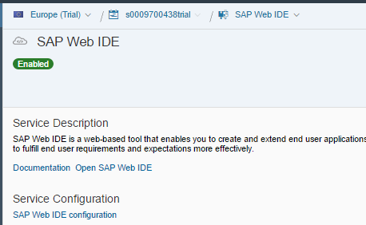

Click **Open SAP Web IDE** to open the Web IDE. The editor will open in a new browser tab. You can also access the Web IDE through the Subscriptions menu item on the left side of the HCP Cockpit screen.

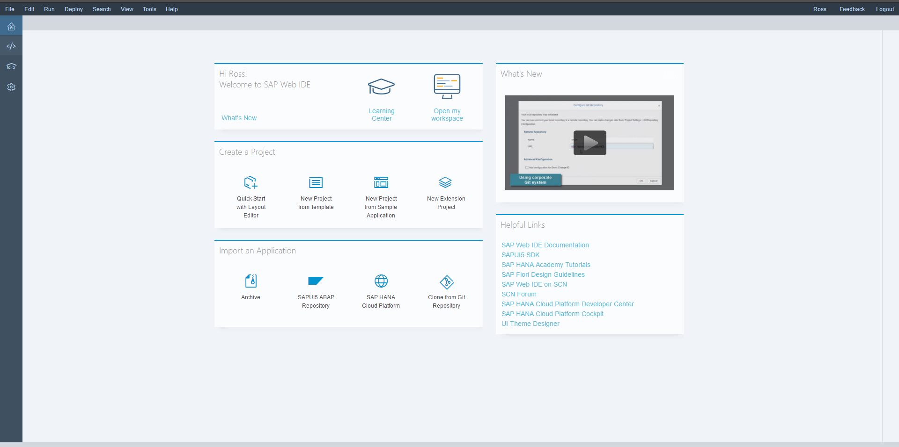

Use the top two icons on the toolbar on the left to toggle between this view and the editor view.



You can bookmark this page and return to it without logging on to the cockpit. You can also access the HCP Cockpit from the Web IDE by using the Tools menu.

## Create the Destination

In order to access your GBI service on the UWM HANA appliance you have to create a destination that servies as a proxy to avoid a cross-domain request. In the HCP Cockpit click **Destinations** on the list to the left of the screen.

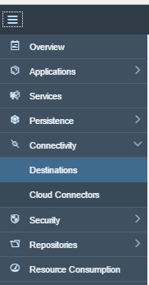

Click **New Destination**.

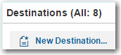

Configure the destination as shown below but substitute your service URL, user id for the UWM HANA system and your password to the UWM HANA system (**Make sure you use the name GBI so when I import your project, it will have the same destination name as I used)**:

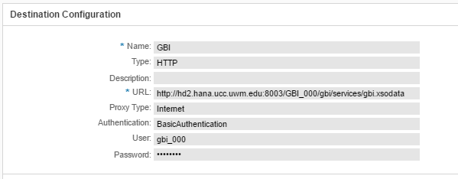

Use the **New Property** button to create the following properties.

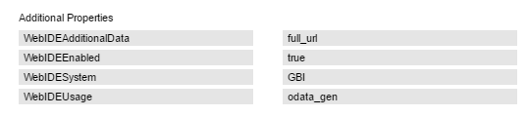

Click save. Once the buttons at the bottom appear, click Check Connection.



# Smart Templates

Smart templates use annotations to create an application. The annotations can be embedded in an OData service or in a separate file. This allows the service developer to determine how the data should be consumed and improves the efficiency of application development because many of the fundamental design decisions and code development are handled automatically. An added benefit is that standards are enforced across different applications for similar types of data types. In our case, there is no annotation information in our service so you will have to create it using the Annotation Modeller.

## Create the Application

In the Web IDE and create a new project from a template either by clicking the icon (If you don’t see this icon, click the  icon on the upper left).

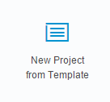

You can also invoke the wizard by using the File menu to select **New → Project from template**. Select the **List Report Application** template and click **Next.**

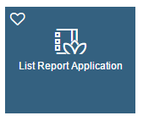

Enter a project name and Title then click **Next**.

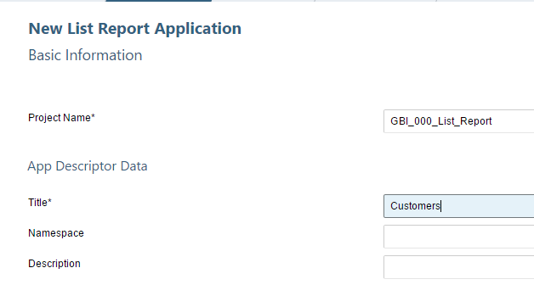

Select Service URL and then select the GBI destination from the dropdown list. Click Next once HCP retrieves the service metadata and gbi.xsodata appears in the Service table.

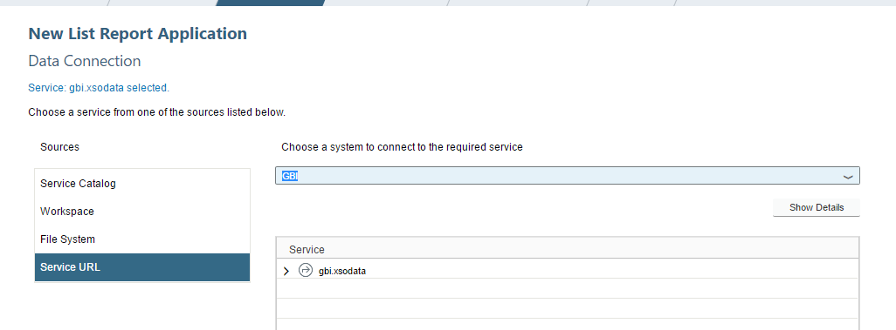

Click + Add Annotation Files and select File System. Select the BASIC_0_Annotations.xml file. Click Next.

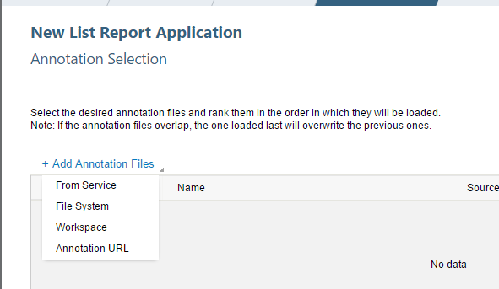

Select the Customers collection and click Finish.

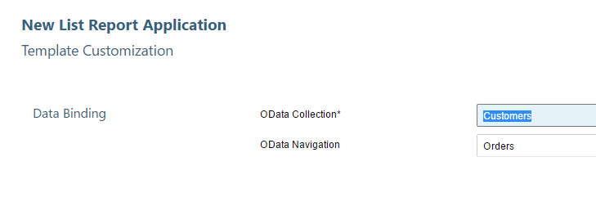

With the project name selected, click the run icon (). When the dialog below appears, select the flpSandbox.html file and click OK.

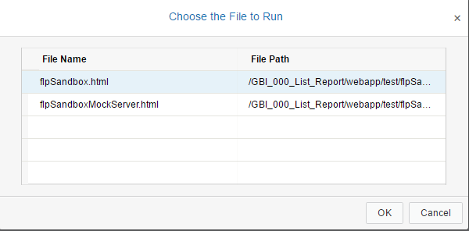

The application appears as a tile on a temporary Fiori Launchpad.

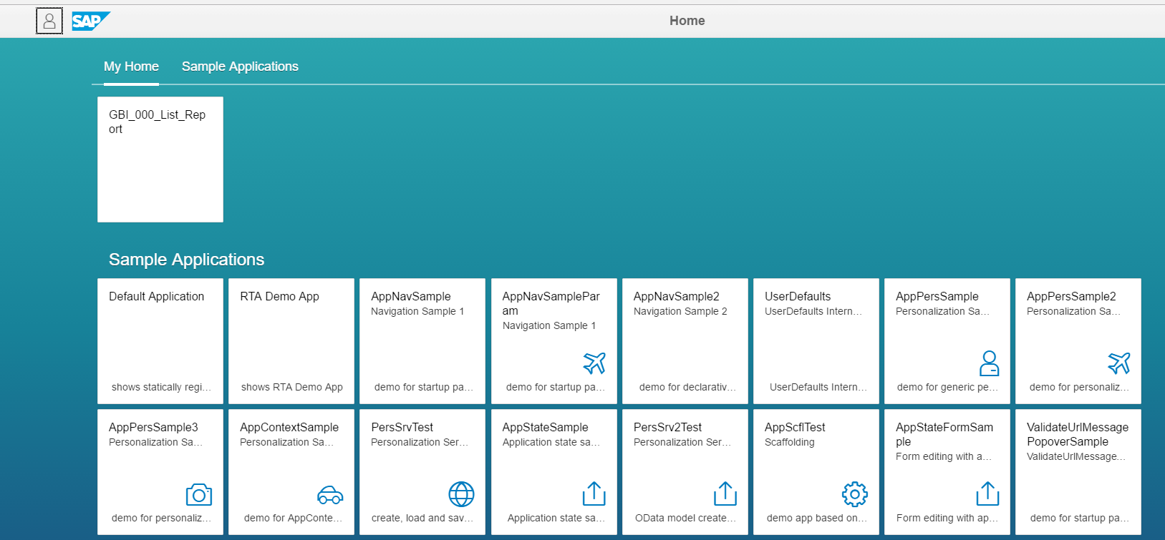

Click the tile to open the application.

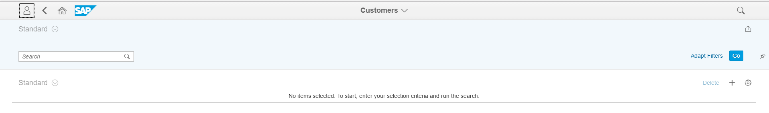

Click the cog  on the right and choose a few fields to display.

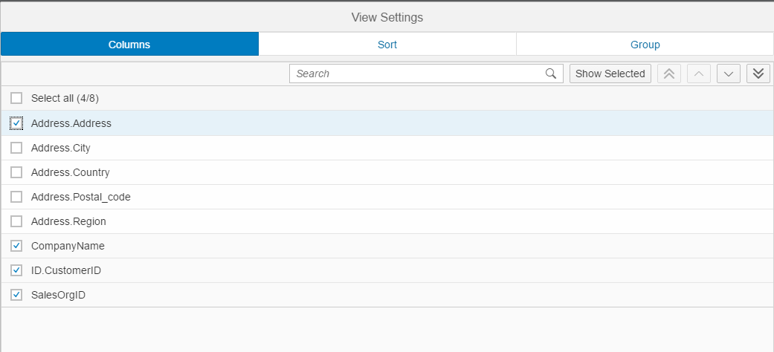

Click .

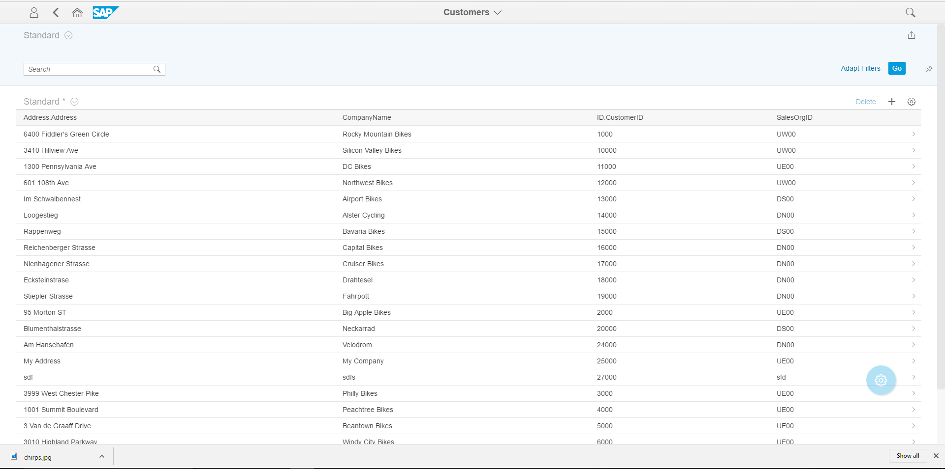

This works but it would be better if we preconfigured what fields to show so the user doesn’t have to do it everytime.

## Configure the App

Back in the WebIDE, expand the project folder and locate the annotations.xml file.

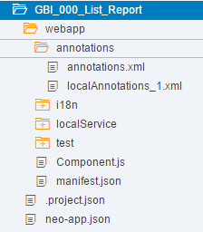

Right-click the file and select **Open With → Annotation Modeller**.

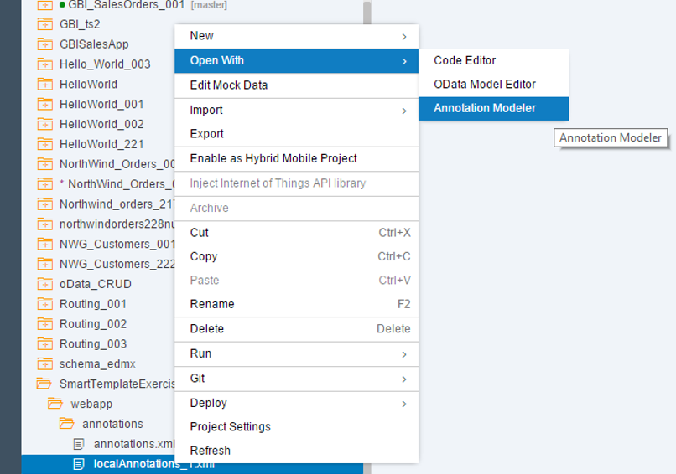

Click the plus sign on the line with the Local Annotations, select **UI.LineItem** and click **OK**.

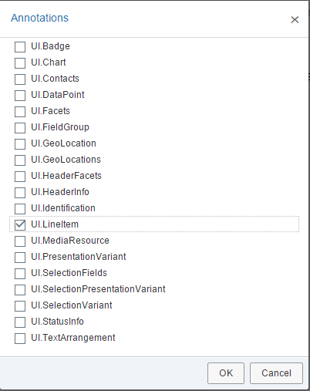

Click the plus sign on the line with the UI.LineItem and select a Datafield.

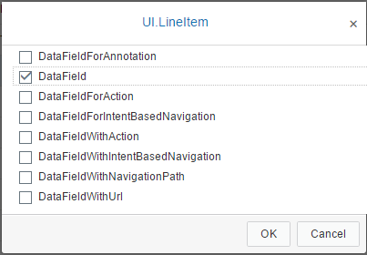

Configure the properties as shown:

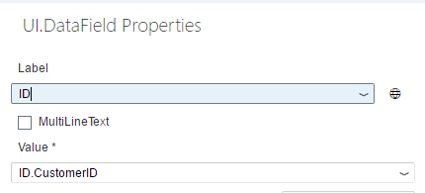

Add two more Datafields configured as shown.

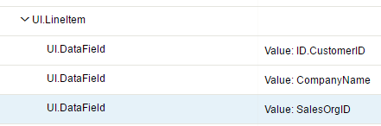

Save the file and refresh the application:

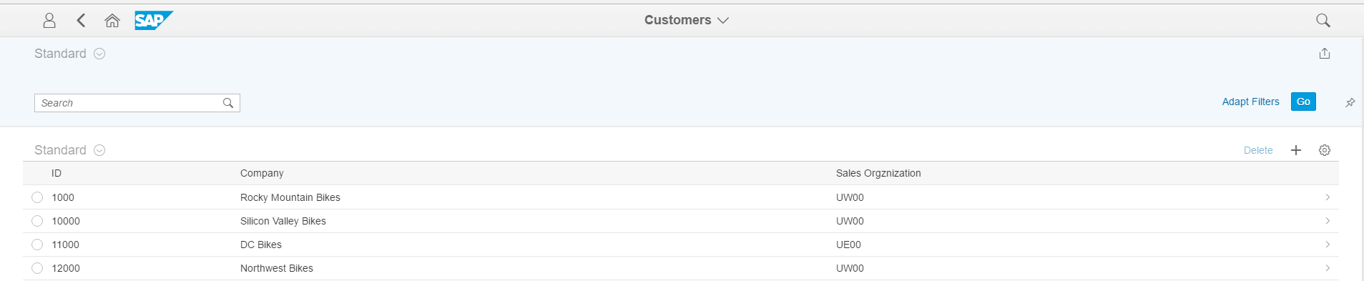

Return to the WebIDE and click the plus sign on the row with Local annotations again to add a **UI.Identification**.

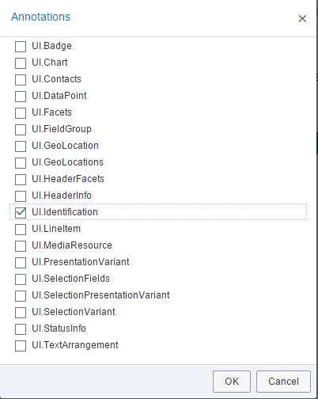

Add the following Datafields to the UI.Identification.

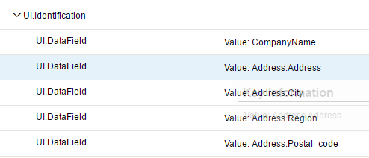

Once you save the annotations and refresh the application, you can click a customer in the table to open a new view with the customer’s address.

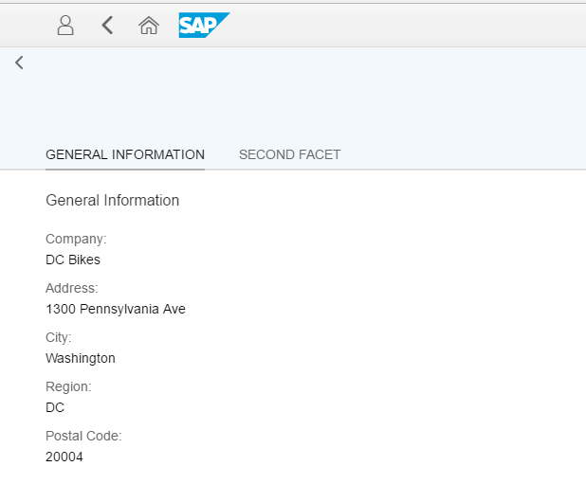

Now, let’s add the sales order details. In the WebIDE, select the SalesOrders collection from the dropdown in the Annotation Modeller.

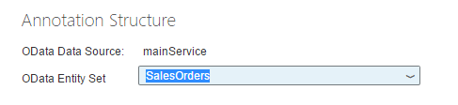

Configure a UI.LineItem and UI.Identification as shown:

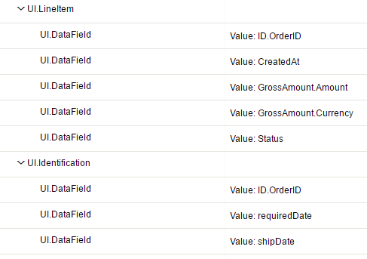

Now, you will see the customer’s sales orders on the second view and if you click a sales order, you will get additional details.

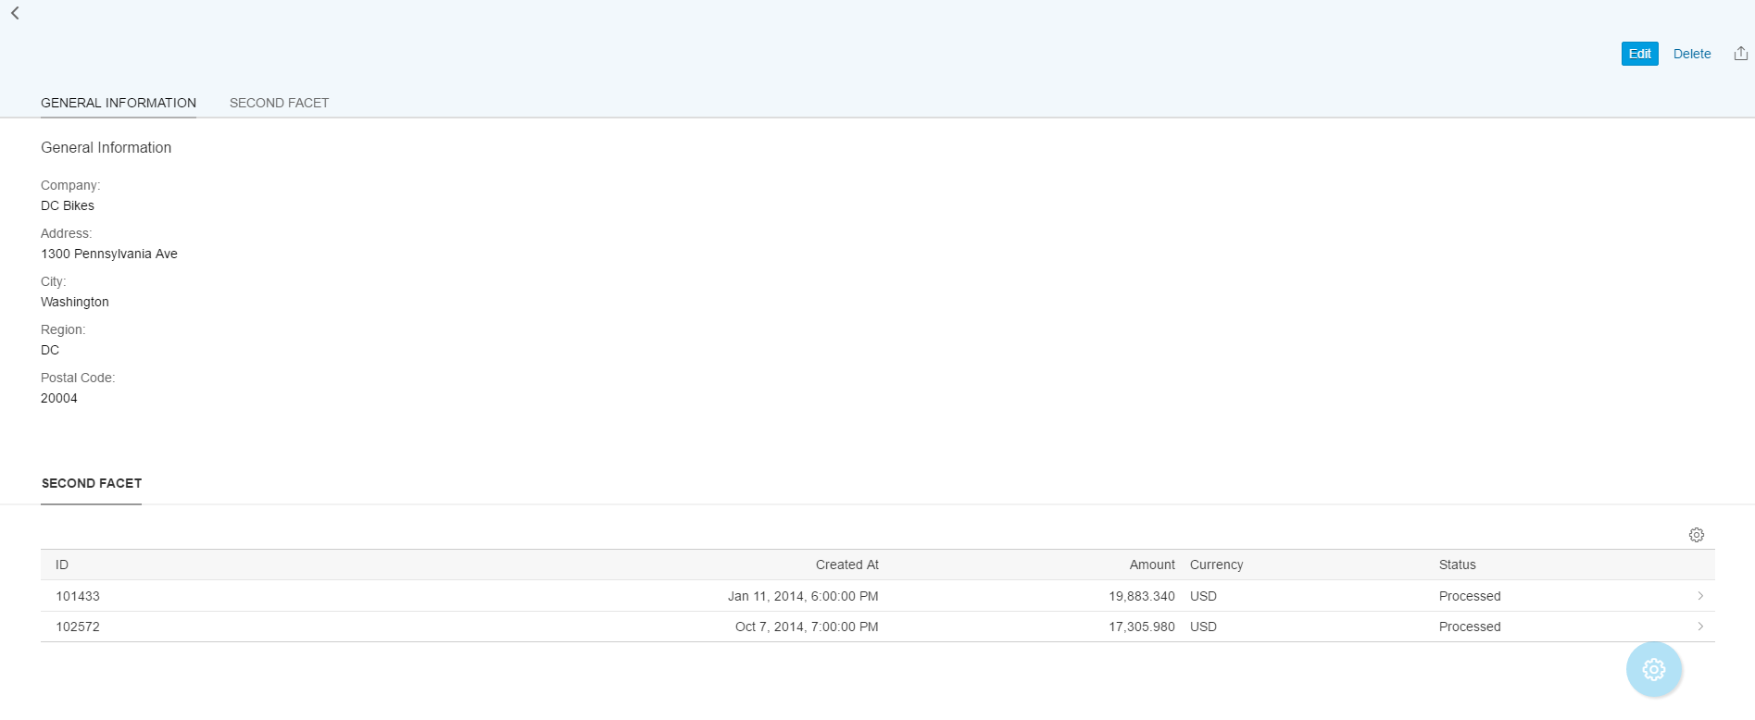

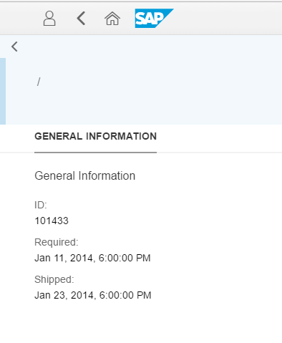

# Turn it in

Use the context menu to export your project to a zip file and upload that file to the dropbox on D2L.